Sentiment Analysis Using Natural Language Processing (NLP)
Comprehensive Beginner-Friendly Guide

Introduction
Sentiment analysis is a branch of Natural Language Processing (NLP) that determines whether a piece of text expresses a positive, negative, or neutral sentiment. It is widely applied across industries for various purposes:
- E-commerce: Analyze customer reviews to enhance product features.
- Social Media: Monitor public opinion on brands or events.
- Customer Support: Evaluate feedback to improve service quality.
Objective
This guide walks through the process of performing sentiment analysis using the Movie Reviews Dataset from NLTK. We will:
- Explore and preprocess text data.
- Extract features using TF-IDF vectorization.
- Build a sentiment classification model using Naive Bayes.
- Evaluate model performance with metrics and visualizations.

What Will You Learn?
- Fundamental text preprocessing techniques.
- Feature extraction methods for text classification.
- Training and evaluating machine learning models for sentiment analysis.
- Generating actionable insights using word clouds and other visualizations.

Dataset Overview
Source
The dataset is sourced from the NLTK Movie Reviews Corpus. It consists of 2,000 movie reviews, categorized into:
- Positive (pos): 1,000 reviews.
- Negative (neg): 1,000 reviews.
Features
Feature Name | Description
Text | Movie review text
Sentiment | Sentiment label (pos/neg)

Applications of the Dataset
- Consumer Feedback Analysis: Identify positive and negative sentiments.
- Market Research: Monitor trends in customer opinions.
- Social Media Analytics: Gauge public sentiment towards campaigns or events.
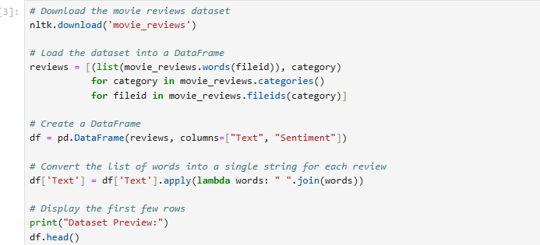
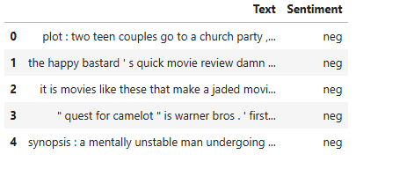

Step 1: Data Exploration
Objective
Before preprocessing, it is essential to understand the dataset's structure. This involves:
- Checking for null or missing values.
- Inspecting sentiment distribution.
- Reviewing example reviews.
Steps
- Dataset Inspection
  - Preview the dataset to understand its structure and content.
  - Check for missing or null values.
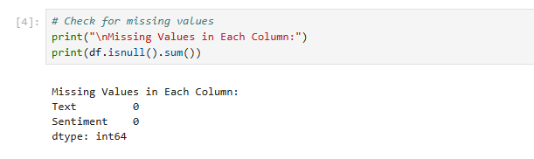

- Sentiment Distribution
  - Visualize the sentiment distribution to ensure a balanced dataset.
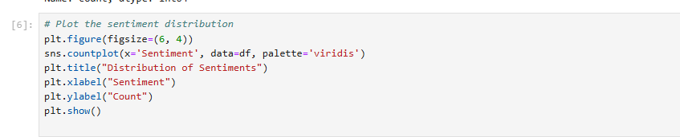
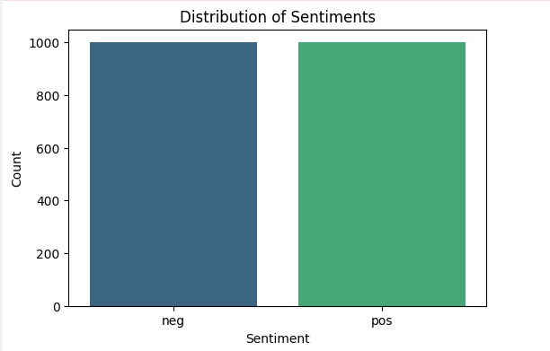

Key Insights:
- The dataset contains an equal number of positive and negative reviews.
- A balanced dataset ensures unbiased model training.

Step 2: Text Preprocessing
Objective
Text preprocessing prepares the data for feature extraction and modeling. This includes:
- Lowercasing: Converts text to lowercase for uniformity.
- Removing Punctuation: Eliminates unnecessary symbols.
- Tokenization: Splits sentences into individual words.
- Stopword Removal: Filters out common words (e.g., "and", "the") that do not add meaning.
- Stemming: Reduces words to their root forms (e.g., "running" → "run").

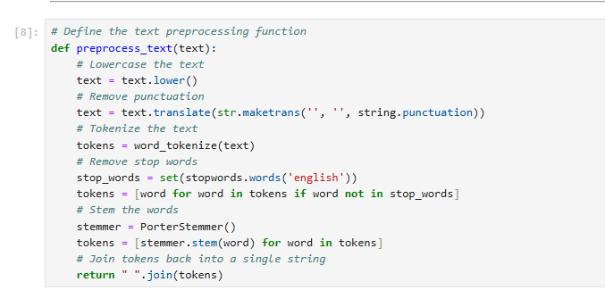

Steps
- Apply the preprocessing function to the Text column.
- Create a new column Cleaned_Text to store the processed text.
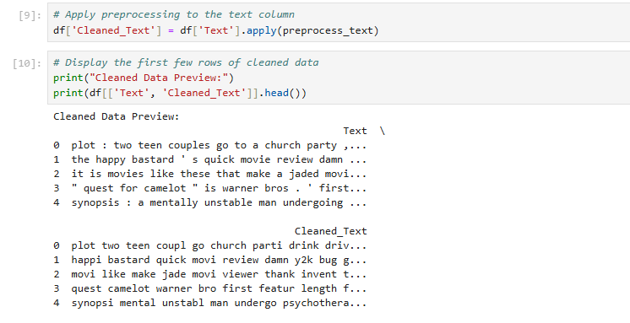

Key Insights:
- Preprocessed text is more suitable for feature extraction.
- Removing noise improves model accuracy and reduces computational complexity.

Step 3: Feature Extraction Using TF-IDF
Objective
Convert the cleaned text into numerical features using TF-IDF Vectorization.
Why TF-IDF?
- It emphasizes important words in a document relative to the entire dataset.
- Reduces the impact of frequently occurring but less meaningful words.

Steps
- Initialize the TfidfVectorizer with a maximum of 3,000 features.
- Transform the Cleaned_Text column into a TF-IDF matrix.

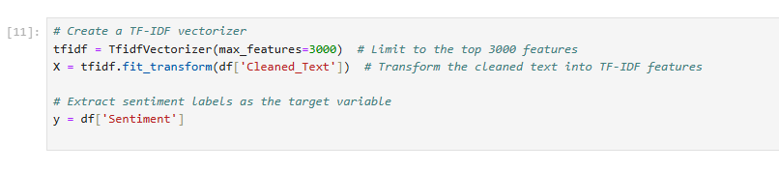

Key Insights:
- TF-IDF captures the importance of words in determining sentiment.
- The resulting matrix is sparse, containing numerical values for each document.

Step 4: Splitting Data into Training and Testing Sets
Objective
Split the dataset into:
- Training Set: Used to train the model.
- Testing Set: Used to evaluate model performance on unseen data.

Steps
- Use an 80-20 split for training and testing.
- Ensure the split maintains the balance of positive and negative sentiments.

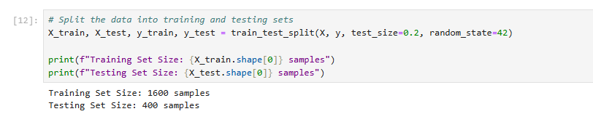

Key Insights:
- Splitting ensures that the model generalizes well to new data.
- A balanced test set avoids bias in performance evaluation.

Step 5: Building the Naive Bayes Model
Objective
Train a Naive Bayes Classifier on the TF-IDF features to classify sentiments.
Why Naive Bayes?
- Simple and effective for text classification tasks.
- Assumes independence between features, suitable for bag-of-words models.

Steps
- Train the MultinomialNB classifier on the training set.
- Predict sentiments for the test set.
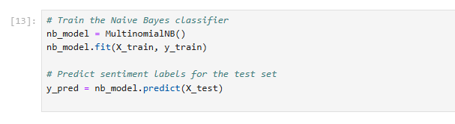

Key Insights:
- The model learns to distinguish positive and negative reviews based on word frequencies.
- Naive Bayes is computationally efficient and interpretable.

Step 6: Model Evaluation
Objective
Evaluate the model's performance using:
- Accuracy: Measures overall correctness.
- Confusion Matrix: Visualizes errors between predicted and actual sentiments.
- Classification Report: Summarizes precision, recall, and F1-score for each class.

Steps
- Calculate accuracy and display the classification report.
- Visualize the confusion matrix to understand error distribution.
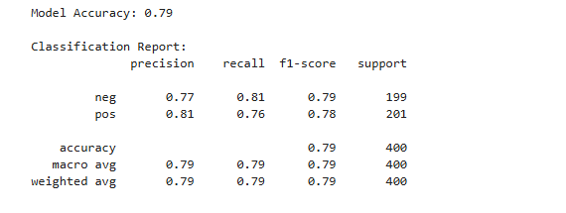
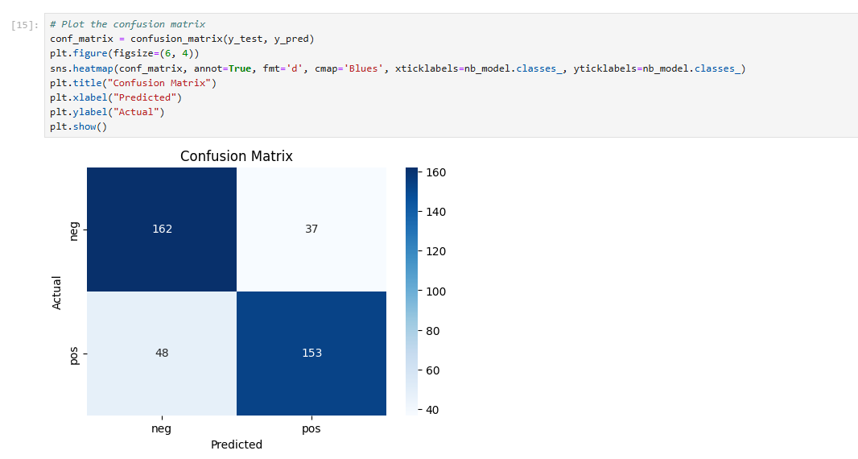

Key Insights:
- High accuracy indicates that the model effectively distinguishes sentiments.
- Precision, recall, and F1-scores provide a detailed view of performance for each sentiment.

Step 7: Visualizing Sentiments Using Word Clouds
Objective
Generate word clouds for positive and negative sentiments to identify frequent words in each class.

Steps
- Combine cleaned text for each sentiment.
- Generate separate word clouds for positive and negative reviews.
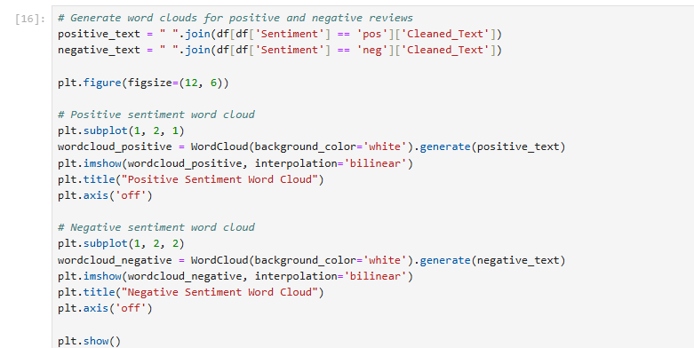

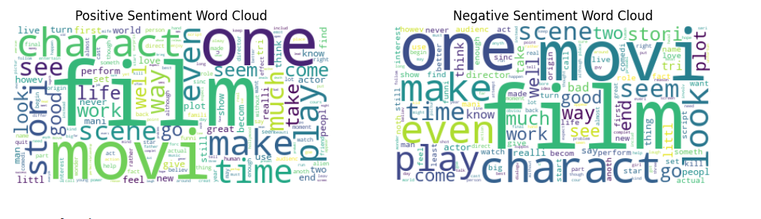

Key Insights:
- Positive sentiment reviews often include words like "excellent" or "amazing."
- Negative sentiment reviews frequently contain terms like "bad" or "worst."

Step 8: Conclusion
Key Takeaways
- Preprocessing Improves Results: Techniques like stopword removal and stemming significantly enhance text quality.
- TF-IDF Effectiveness: TF-IDF converts text into meaningful numerical features that capture sentiment.
- Naive Bayes Strengths: A straightforward yet powerful model for text classification, achieving high accuracy on balanced datasets.

Applications
- E-commerce: Analyzing customer reviews to improve products and services.
- Social Media Analytics: Monitoring brand reputation in real time.
- Customer Support: Automatically flagging negative reviews for immediate attention.

Future Directions
- Explore advanced models like Logistic Regression or Neural Networks.
- Use external datasets to improve model generalization.
- Experiment with deep learning methods, such as BERT or LSTMs, for more nuanced sentiment analysis.

References
- Bird, S., Klein, E., & Loper, E. (2009). Natural Language Processing with Python. O'Reilly Media.
- Scikit-learn Documentation. (2023). Naive Bayes. Retrieved from scikit-learn.org.
- NLTK Documentation. (2023). Movie Reviews Corpus. Retrieved from nltk.org.

